21 August 2018

Dr Kathy McNutt
Faculty of Graduate Studies
University of Regina

Re: Verbal response to External Review

Dear Dr McNutt:

Thank you for meeting with CCAM on Monday 20 August to discuss the External Reviewers’ Report and provide us with your preliminary response. Your written response to CCAM was very helpful. We equally hope that our discussion today will be useful as you craft your unit’s next response to the report. We are very pleased to see that the new Dean has fully engaged the reviewers’ recommendations and has begun to implement some of these such as campus-wide consultations and communications initiatives.

While we do not want your next response to repeat at length the material already in the Self-Study, we would appreciate if your written response would, when thinking of the External Reviewers’ Report, touch upon the following areas, taken from the Academic Unit Review Operations Manual (OPS-130-005):

"These reviews will focus on the following areas when and where appropriate:

- the priorities and aspirations of each unit and the extent to which they are being realized
- the challenges and opportunities faced by the unit
- the structure and quality of undergraduate and graduate programs and instruction
- the contribution of each program to related disciplines and fields of study
- the scope and significance of research being pursued
- the degree to which academic programs meet students' learning needs and goals
- the characteristics of staffing complements
- the degree to which the unit is meeting its internal and external service responsibilities
- the role the unit plays in meeting the University's vision, mission, goals and priorities
- the financial resources of the unit"

Furthermore, and in particular, it would be useful to the committee that your written response will provide:

- an elaboration on any report recommendations your unit disagrees with
- further developments on your initial response presented to the committee

The committee looks forward to meeting with the unit again in 15 – 18 months to discuss the health of the unit and its engagement with the recommendations of the review. In five-years’ time it is anticipated that the unit will submit a final update to CCAM.

We look forward to your unit's formal written response.

Sincerely,

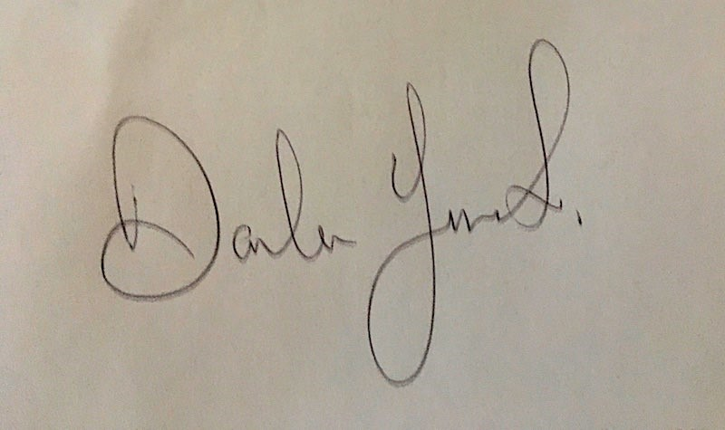

Darlene Juschka, Chair
Council Committee on Academic Mission

cc: Dr Thomas Chase, Provost and Vice-President Academic
Dr David Malloy, Vice-President Research

